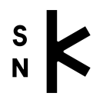
Application
Ars typographica antiqua
21st – 23rd April2026
Slovak National Library, Martin
Name, surname, title:

Institution:

Adress (permanent residence)/ phone, e-mail:

Date of birth (it is required for the license agreement, fill up only if you are interested in publishing in the journal Kniha):

Name of the contribution:

Annotation (min. 200 words):

